References Demo

See demo on youtube: <http://youtu.be/BwsNEw8prJM>

1. Open up the project called “ReferencesDemoStart”

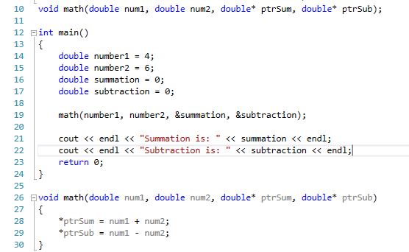

1. Change this so that it uses references instead of pointers:
   1. First change the function:

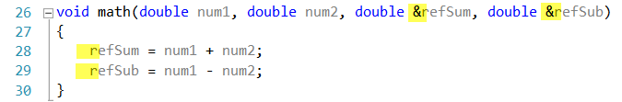

* 1. Notice the use of & vs \*. Also notice we just use refSum instead of \*ptrSum in the body of the Function.
  2. Next at the top of the program change the function prototype:

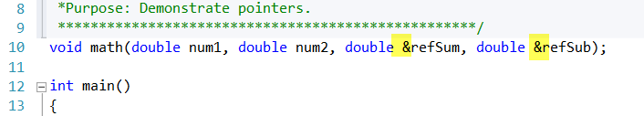

* 1. Finally change the function call in main:



* 1. Notice we no longer pass the address of summation and subtraction. Instead we pass in just the variables.
  2. Your program should now look like this:

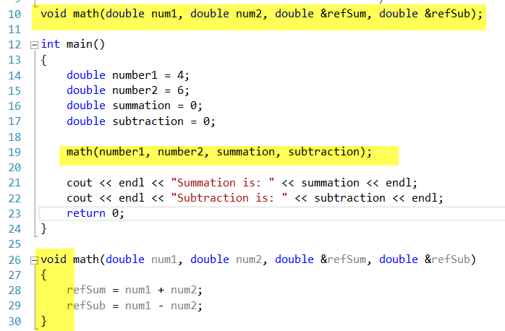

* 1. Try it with Ctrl-F5

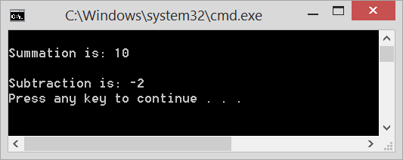

* 1. Notice that it works the same with references as with pointers.